 | PRESS RELEASE  IFTS, Inc. USA  200 Pond Avenue  Middlesex, NJ 08846  www.ifts-usa.com
PRESS INQUIRIES
Christina Mazza, Marketing
(732) 629-7548
christina.mazza@ifts-usa.com

For Immediate Release August 13, 2012

IFTS, Inc. wins New Product of the Year Award

In June, the American Filtration and Separations Society (AFS) held their annual Spring Conference in Boca Raton, FL where IFTS, Inc. was awarded the New Product of the Year award for the Global Fuel Water Separation (FWS) Filter Efficiency Test Stand. The conference recognizes current and emerging industry leaders.

The FWS test equipment allows for the measurement of the fuel/water separation efficiency of diesel fuel filters for road and off-road vehicle combustion engines according to American, European, and international standard methods.

In 2011, IFTS, Inc. and Sigma Design Company developed and fabricated a liquid filter test stand for mission critical vehicles used by the Egyptian Army. The state-of-the-art testing system was designed to perform qualification tests on diesel and petrol fuel filters in accordance with ISO 4020.

IFTS, Inc. is now designing/fabricating new Liquid Filter Test Stands in New Jersey.

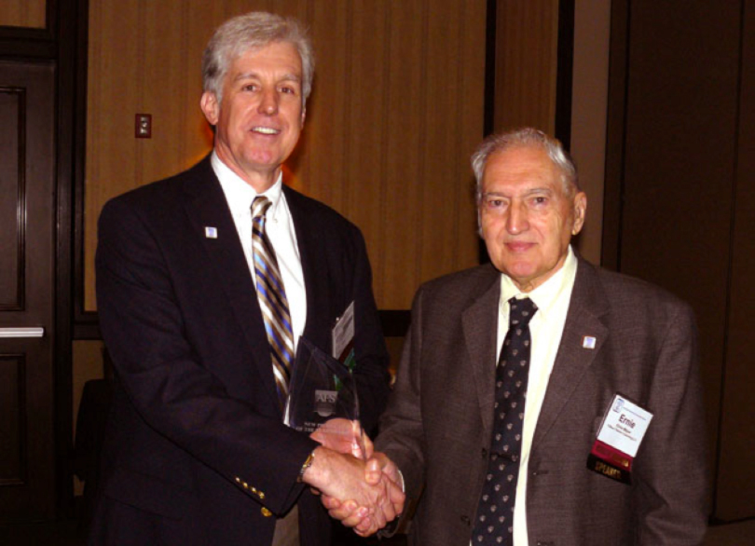
Gerard (Jerry) J. Lynch, P.E. president of IFTS, Inc. USA left, accepting the New Product of the Year Award from Dr. Ernest Mayer, chair of the AFS Users Committee which judges the entries.

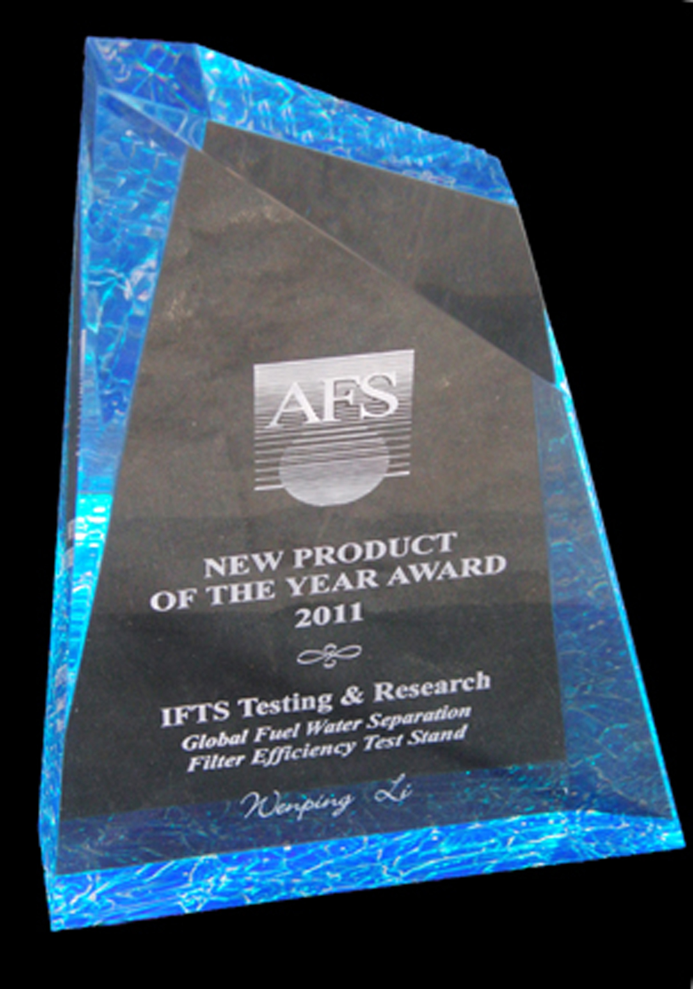
The AFS New Product of the Year Award 2011

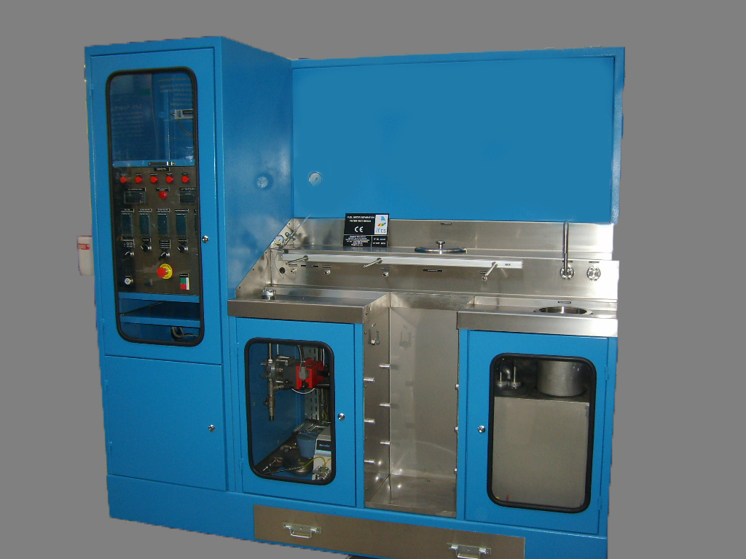
IFTS, Inc.'s Global Fuel Water Separation (FWS) Filter Efficiency Test Stand

About IFTS, Inc. USA

International Filter Testing Services (IFTS) is an independently regulated, ISO 17025 accredited, laboratory and research center focusing on liquid filtration and separation science. IFTS has locations in Europe, USA and China, providing filtration testing and research services for many industries. The management at IFTS has compiled a world-class team of scientists, engineers and technicians in the field of Solid- Liquid Separation. IFTS provides a global resource for professionals working in Solid- Liquid Separation (SLS). Learn more at http://www.ifts-usa.com.

###

